Project Design Phase-II
Technology Stack (Architecture & Stack)
Date | 18 June 2026
Team ID | __________
Project Name | ShopEZ
Maximum Marks | 4 Marks

Technical Architecture Diagram
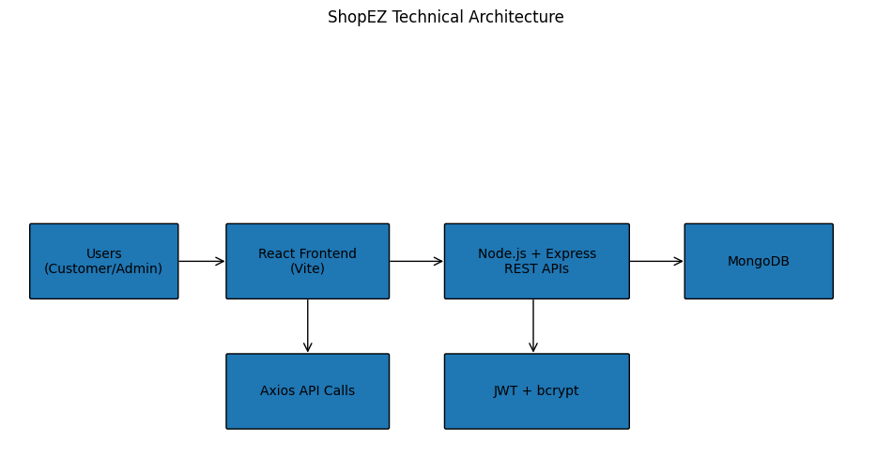

Table-1: Components & Technologies
S.No | Component | Description | Technology
1 | User Interface | Customer and Admin interfaces | React.js, Vite, CSS
2 | Application Logic | Frontend business logic | React Components, Hooks
3 | Backend Logic | REST API processing | Node.js, Express.js
4 | Database | Store users, products, carts, orders | MongoDB, Mongoose
5 | Authentication | User authentication | JWT, bcrypt
6 | API Communication | Frontend-backend communication | Axios
7 | Version Control | Source code management | Git, GitHub
8 | Development Tools | Coding and testing | VS Code, Postman

Table-2: Application Characteristics
S.No | Characteristics | Description | Technology
1 | Open Source Frameworks | Frameworks used in project | React.js, Express.js, Node.js
2 | Security | Authentication and password security | JWT, bcrypt
3 | Scalable Architecture | Supports future enhancements | MERN Stack
4 | Availability | Accessible through web browser | Localhost / Cloud Deployable
5 | Performance | Fast API response and UI rendering | React, Express, MongoDB

